MGT 6203 Group Project Proposal Team 27

**Please edit the following template to record your responses and provide details on your project plan.**

**TEAM INFORMATION (1 point)**

**Team #:** 27

**Team Members:**

1. Kerri Robinson; krobinson78
   1. Graduated from the University of South Carolina in 2018 with a degree in Math. Then started working as a Data Analyst at Bank of America in the Quantitative Rotational Program for 2 years. After the Program I joined the Consumer Credit Card Strategies Team as a Data Analyst and have been there for 2 years. I analyze different credit card strategies to help create criteria and exclusions to meet loss expectations. Last semester in CSE 6242, my group and I created a data visualization in Tableau that showed the relationship between different podcasts based on a cosine similarity score. We took the transcripts from episodes and created keywords for each episode and then the top keywords for each show. Then calculated a similarity score based off of the number of similar keywords between shows. The interactive visualization was a network graph where users could use filters or select on a node and all similar nodes would be highlighted.

[Insert background information: Name, professional background, education background, previous analytics related projects you have worked on]

1. Andrew McAlister; amcalister7
   1. Graduated from Purdue University in 2007 with a BS in Computer & Information Technology. Worked from 2007 to 2012 for Bank of America as a Business Analyst supporting internal reporting for deals and AML/KYCS for their Corporate and Investment Bank. Since 2012, I’ve been working at Premier in their clinical intelligence department. I’m currently a Product Manager developing quality dashboards that help acute-care hospitals track and predict performance in several national regulatory and public ratings programs. This is my 3rd class in OMSA and first group analytics project.
2. Felipe Gastaldi; fgastaldi3
   1. Graduated from Boston College in 2018 with a BS in Marketing and Finance and a Minor in French. Worked in management consulting for Heidrick & Struggles for 1.5 years before transitioning to Nike/Converse. Currently working as a Product Solution Manager, Digital Workflow focused on creating workflows using robotic process automation and SmartSheet for the digital product creation group. Work closely with product, design, merchandising, and development to streamline and expedite the product creation process. Started in OMSA in Spring 2022 and this is my 2nd class. Previously completed ISYE 6501. Most recently built a revenue tracking visualization dashboard in Tableau for Converse that allowed the Global Merchandising function to dynamically view performance based on geography and product offering. This dashboard enabled an 80/20 analysis that has led to cutting 80% of products from the carryover line (products that exist across multiple seasons and replace new offering).
3. Swathi M. Naik; SNAIK72

Graduated from Mumbai University in 2008 with a BE in Electronics and Telecommunication Engineering. Worked from 2008 to 2013 for TATA Consultancy Services as an Oracle Developer in banking and Finance domain. Worked with Accenture till 2015 for a French Telecommunication Project as an Oracle Developer. Worked with Concentrix from 2017 to 2018 as a PL/SQL and Salesforce Developer for Automotive clients. Later worked for FORD Motor Company as a contractor from 2021 till 2022 as a Product Designer. Currently, I am working for the Life Sciences Company AXTRIA on Snowflake and IICS technologies. This is my second subject in the course. I enjoyed learning ISYE 6501 in the previous semester

1. Changhong Guan, GT Id: cguan8
   1. BS from Harbin Institute of Technology, major in control science, focused on guided missile. MS from NCSU, major in mechanical engineering, focused on MEMS. Worked in consumer electronics market for 12 years, developed products including monitors, antennas, set-top-boxes, speakers, etc. Now I am looking for a career path change in data analytics.

**OBJECTIVE/PROBLEM (5 points) - Andrew**

**Project Title:**

**Background Information on chosen project topic:**

Due to various reasons including changes in energy cost dynamics, advancements in new technologies, response to climate change, and geopolitical pressures, there has been a steady push for developed nations to shift from heavy reliance on fossil fuels and into more alternative sources of energy. While this push is continuing and growing every day there’s still a heavy reliance by European nations (as it is with most nations) on oil.

Traditionally, Russia has been the primary supplier of oil to its European neighbors. In response to the Russian invasion of Ukraine in 2022, nations in the EU have systemically imposed economic sanctions on Russia and as a result are facing a reality of being cut off from the Russian oil supply. While short-term arrangements with alternative suppliers are in the works it’s clear this global trade shift will add even more increased pressure on the adoption of alternative energy.

Some European nations like Germany and France have had more advanced developments in the search for alternative energy sources and have largely mapped out their future progressions. However, there are still countries in a less-advanced state of alternative energy adoption. It will be critical for energy suppliers to project where those countries are headed and seize on these growth opportunities while these added pressures are in place for adoption of their technologies.

**Problem Statement (clear and concise statement explaining purpose of your analysis and investigation):**

Analyzing historical alternative energy trends with the most advanced European countries how can we project the future alternative energy adoption for less-sophisticated European countries and project how key energy companies might financially benefit from their adoption?

**State your Primary Research Question (RQ):**

Focusing on a European nation that is less advanced at adopting alternative energy, like Poland, how could their future increased adoption due to new market pressures financially impact the top wind energy companies in the European market?

**Add some possible Supporting Research Questions (2-4 RQs that support problem statement):**

1. What does Poland’s future wind adoption rate look like?
2. Can we leverage historical wind adoption rates from a more advanced European nation like Germany to project for a country like Poland?
3. Does climate data support a similar adoption rate for Poland as it does for Germany?
4. With projected revenues increasing for our key wind energy providers what sort of impact will that have on their projected stock prices?

**Business Justification:** **(Why is this problem interesting to solve from a business viewpoint? Try to quantify the financial, marketing or operational aspects and implications of this problem, as if you were running a company, non-profit organization, city or government that is encountering this problem.)**

Large energy companies are some of the most heavily analyzed publicly traded companies. Models are routinely built to project their future energy growth forecasts along with any outside factors that could alter those forecasts like climate data or changes in public policy. What is less likely to be included in most models is sudden and large shifts in policy due to less predictable events like pandemics or wars.

Russia’s invasion of Ukraine and the resulting geopolitical reactions to that have caused a massive shift in the economics of the energy markets on top of the changes already being felt by the COVID-19 pandemic. These shifts can provide massive opportunities for changes in energy policy and for new market dynamics to benefit key market players that are positioned to do so.

This analysis will allow us to try to predict one potential shift in this market and the resulting opportunities key companies will have to take advantage of it. The result will be data that those companies could use to set their corporate strategy or for outside investors to predict those moves in hopes of investing before that growth occurs.

**DATASET/PLAN FOR DATA (4 points) -**

1. Energy data: from Our world in data,

<https://github.com/owid/energy-data>

<https://ourworldindata.org/energy-key-charts>

Data is on energy consumption (primary energy, per capita, and growth rates), energy mix, electricity mix and other relevant metrics. The key variables we are interested in are, "year" "country" "wind_electricity" "gdp" "population".

Screenshot:

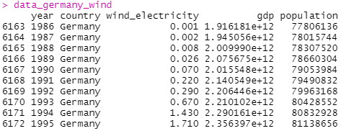

1. Wind turbine market share,

<https://www.statista.com/statistics/272813/market-share-of-the-leading-wind-turbine-manufacturers-worldwide/>

Pie chart of companies' market share in wind turbines business.

1. Vestas and Gamesa financial reports,

<https://www.vestas.com/en/investor/reports-and-presentations/vestas-reporting>

<https://www.siemensgamesa.com/en-int/investors-and-shareholders/financial-information/annual-reports>

Here we mainly focus on revenue,

Screenshot:

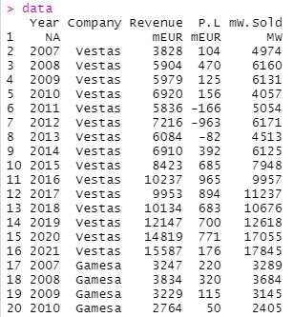

1. Vestas and Gamesa stock price, from yahoo finance,

<https://finance.yahoo.com/quote/GCTAY/history?p=GCTAY>

<https://finance.yahoo.com/quote/VWDRY/history?p=VWDRY>

Stock price of two tickers. We are only interested in “date” and “Adj.Close” price.

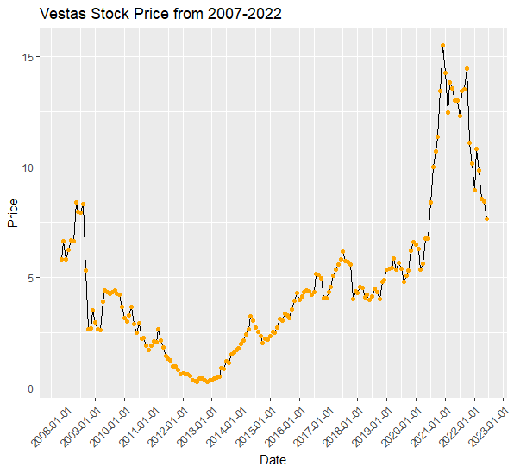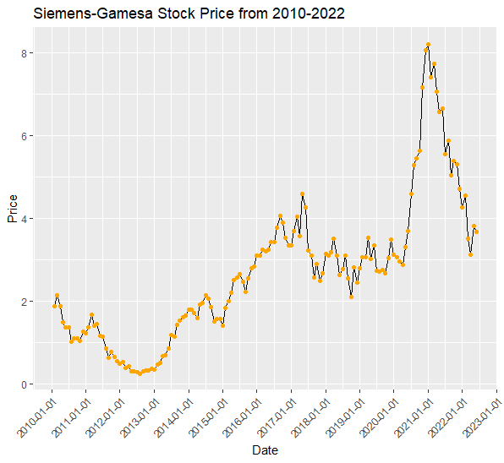

**Data Description (describe each of your data sources, include screenshots of a few rows of data):**

**Key Variables: (which ones will be considered independent and dependent? Are you going to create new variables?** **What variables do you hypothesize beforehand to be most important?)**

**APPROACH/METHODOLOGY (8 points) - ChrisG**

**Planned Approach (In paragraph(s), describe the approach you will take and what are the models you will try to use? Mention any data transformations that would need to happen. How do you plan to compare your models? How do you plan to train and optimize your model hyper-parameters?))**

**Pre Russian-Ukraine conflict**

Germany Case

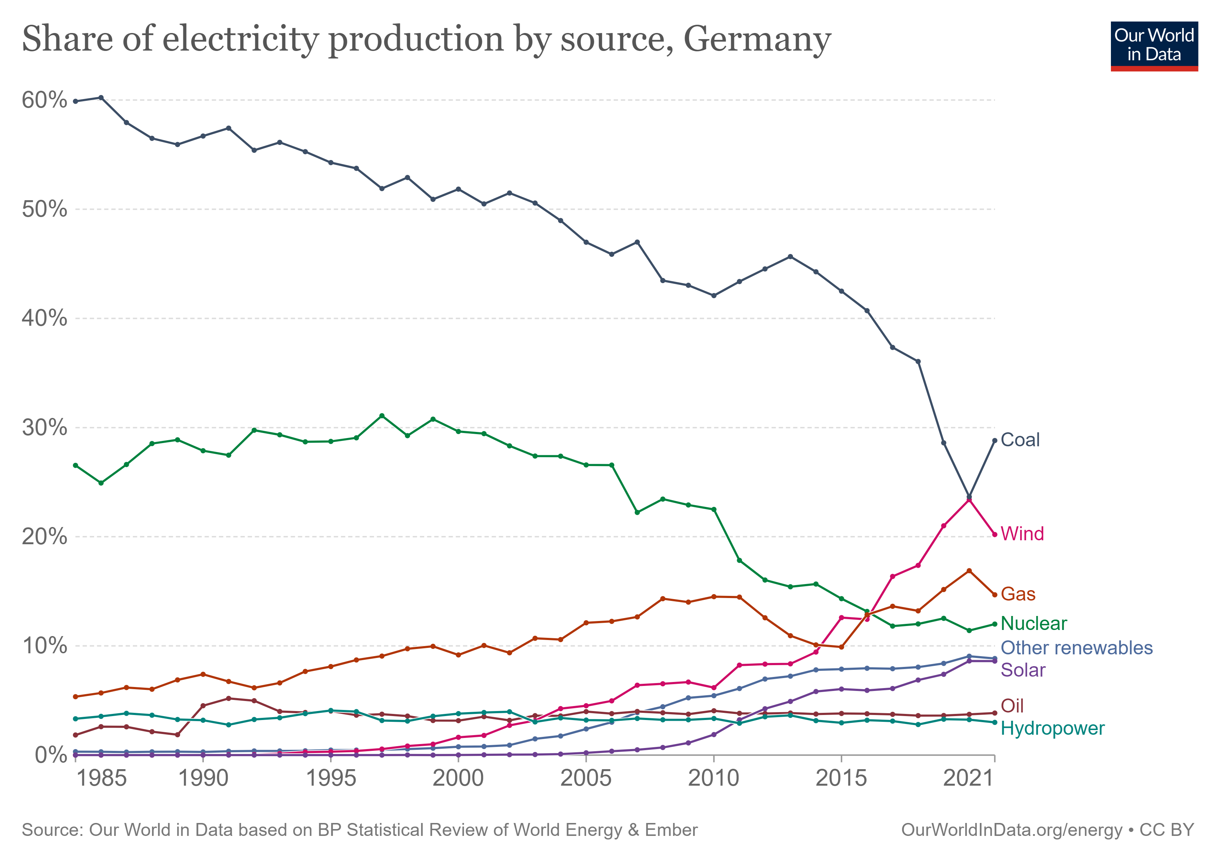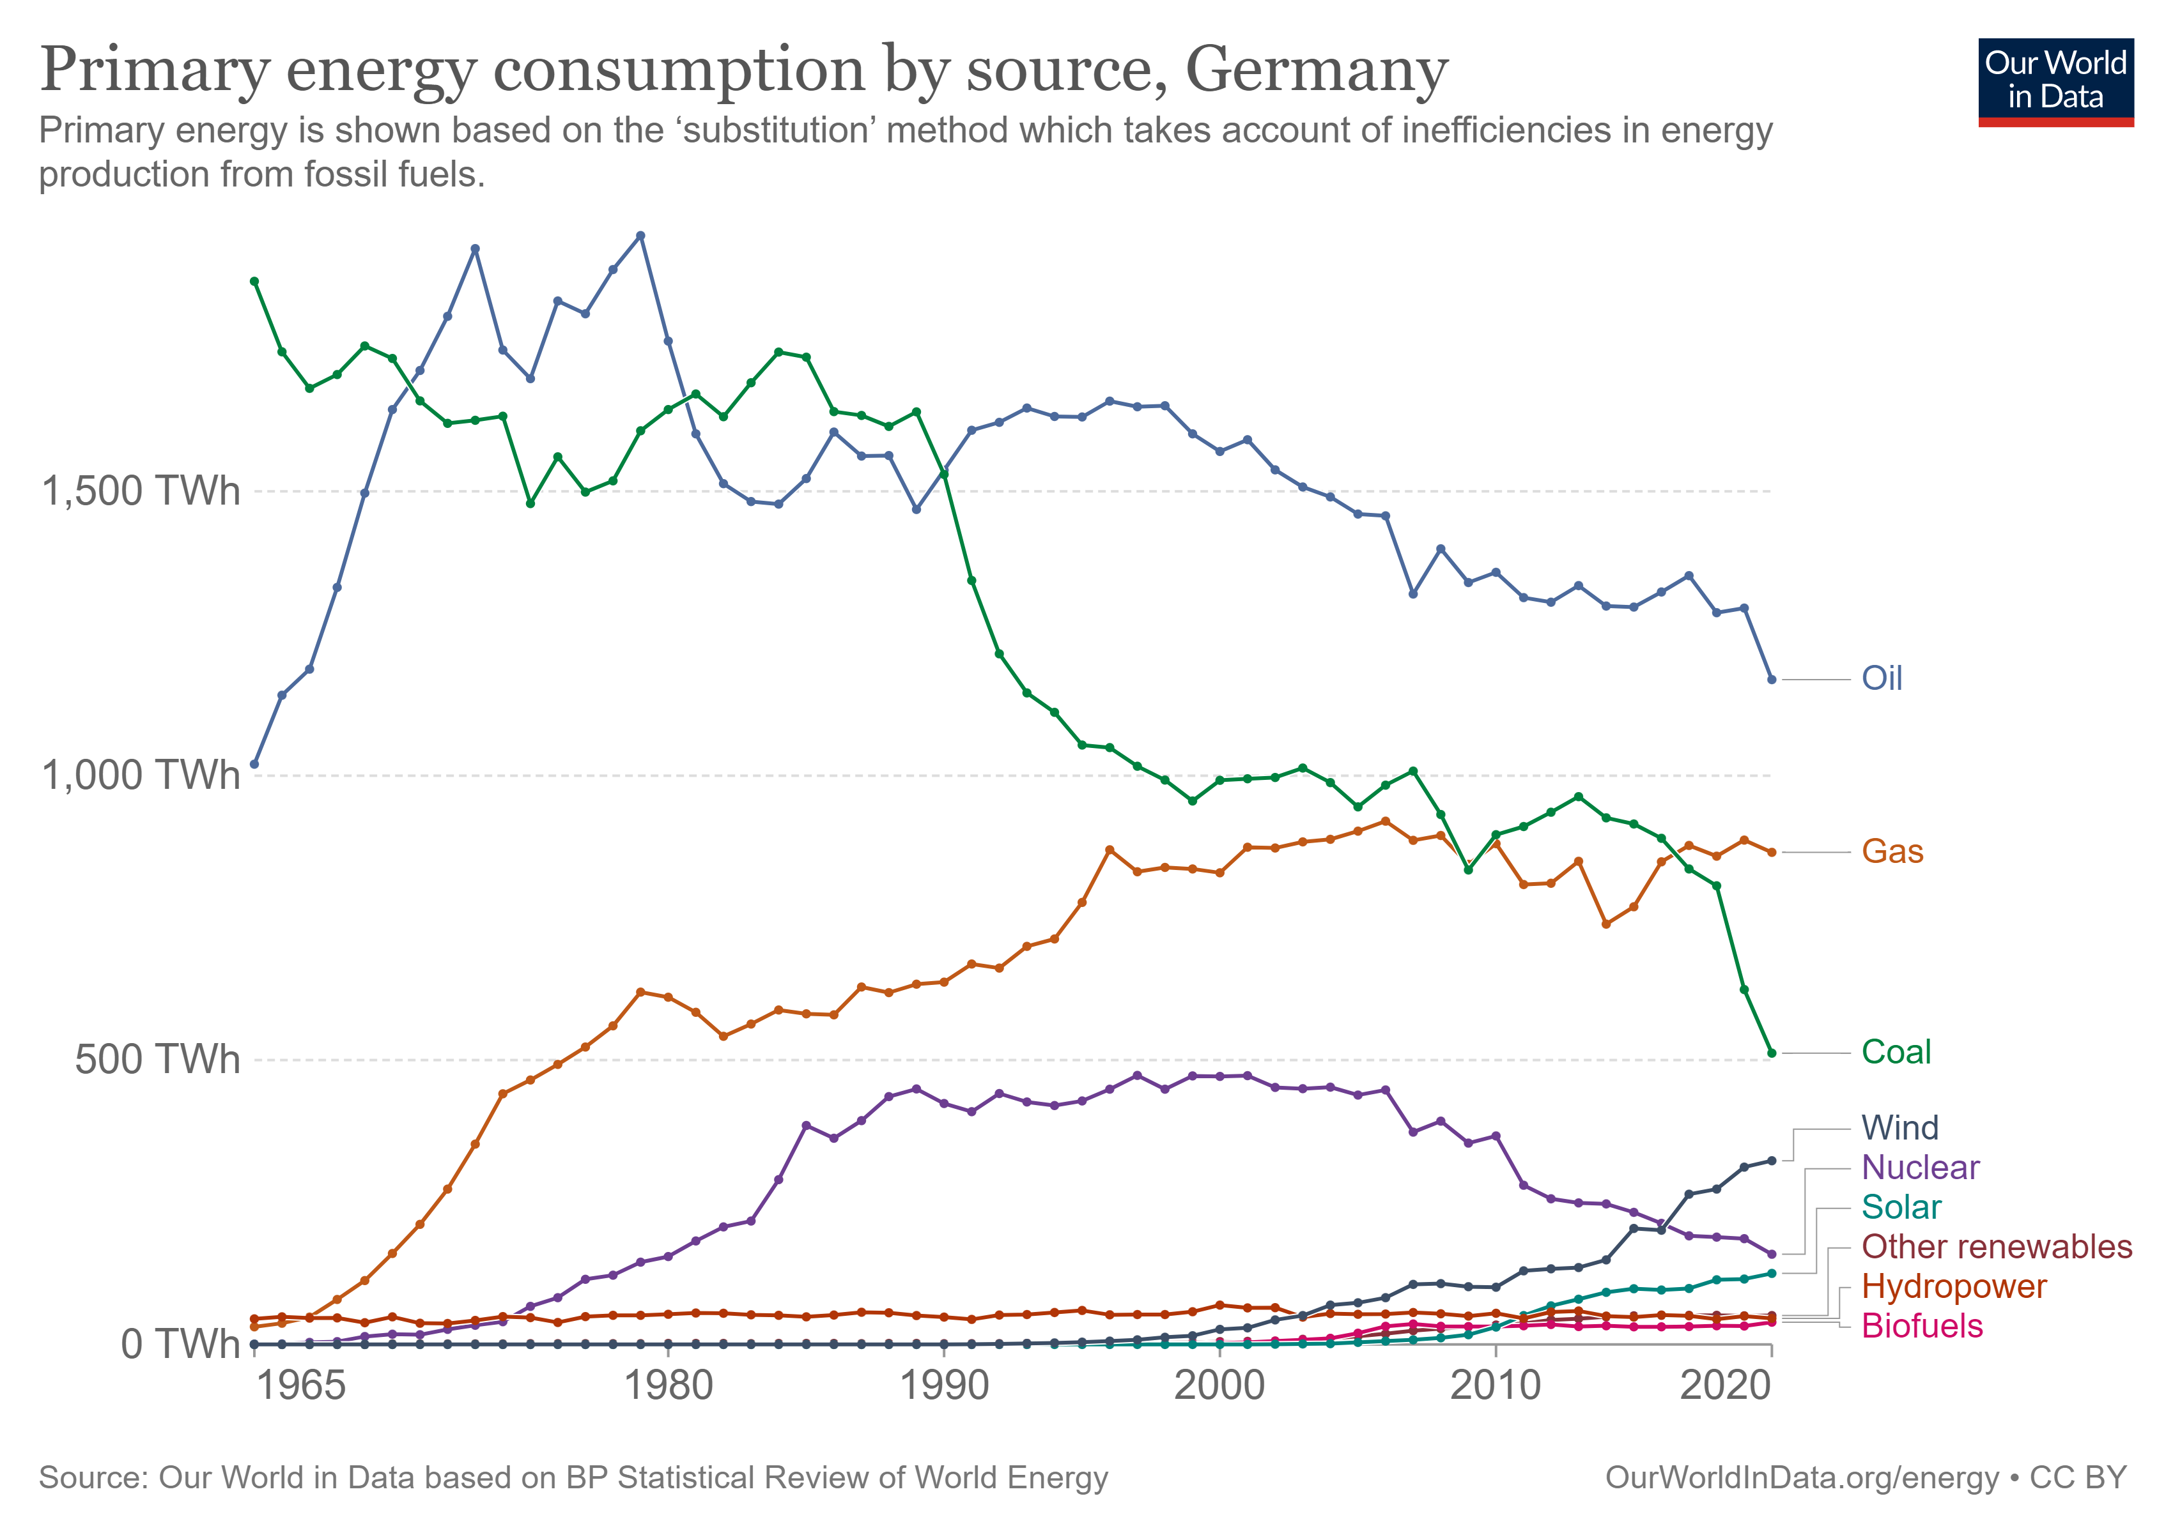

Observed, wind is the fastest growing renewable energy source in Germany, in both volume and percentage.

Use simple linear regression (SLR) model, dependent variable (electricity from wind), independent variable (year), to find lambda for BoxCox transformation.

Apply BoxCox transformation on dependent variable, and re-train SLR model.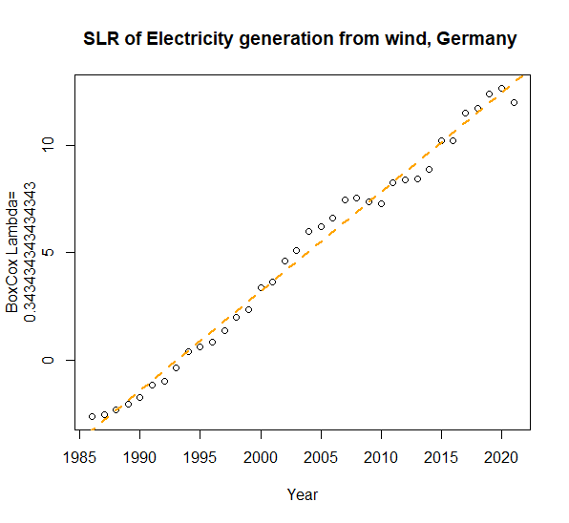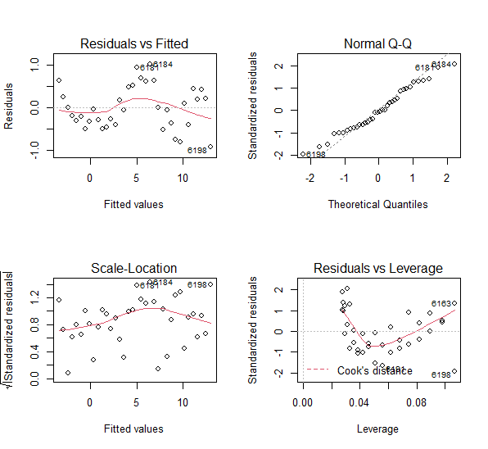

Analyze SLR model assumptions, make sure model is valid.

Then get next 15 years prediction

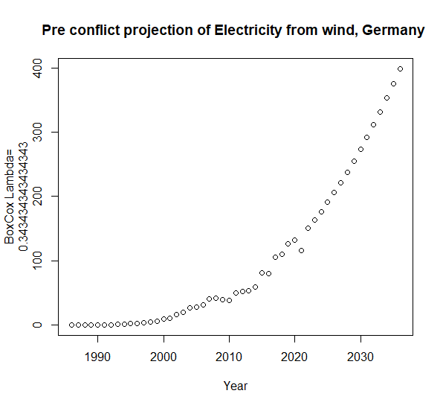

Poland Case

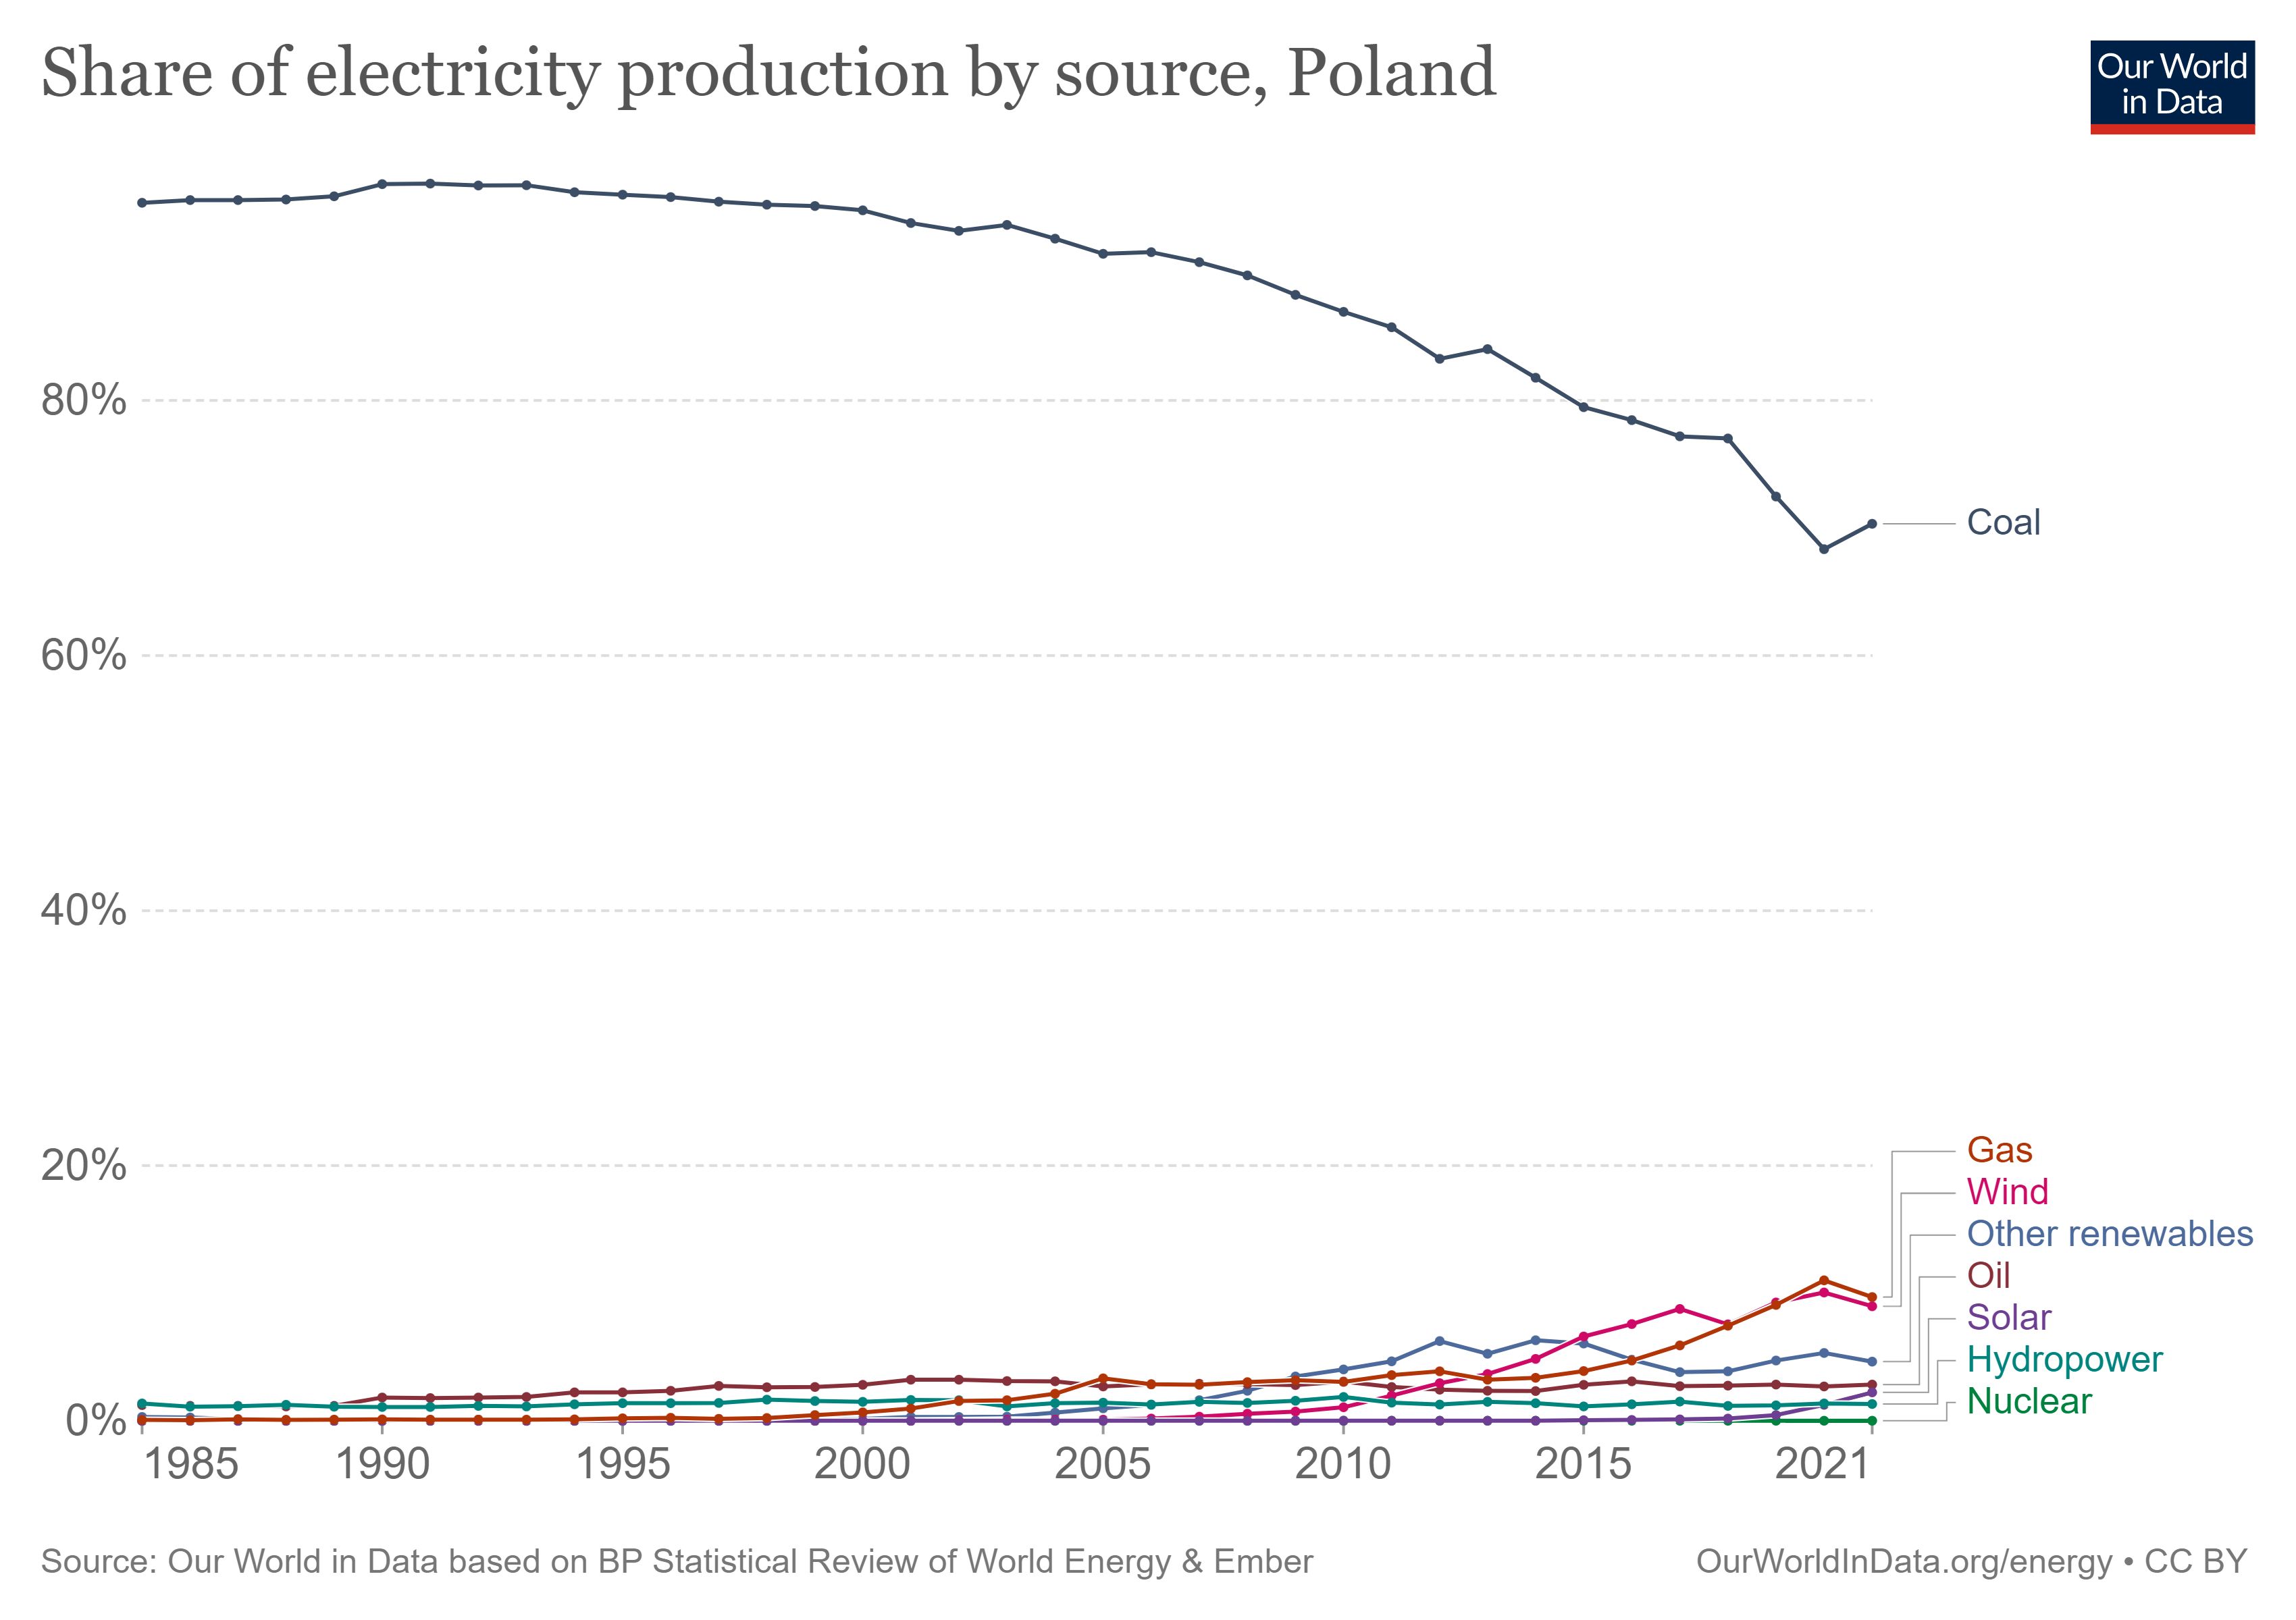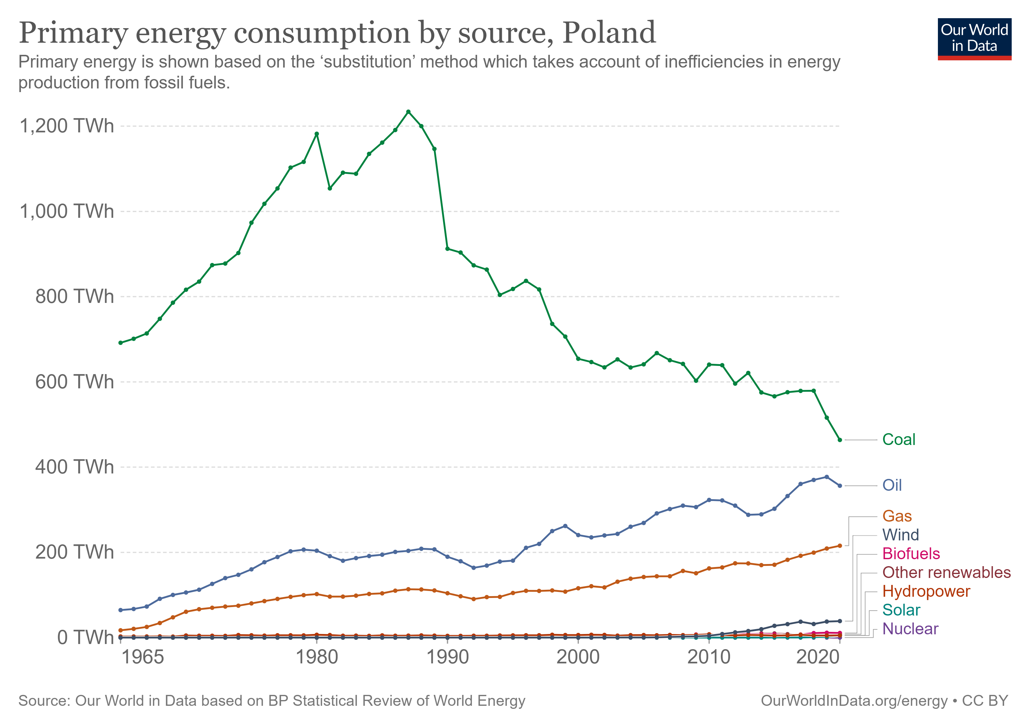

Observed, wind energy is still at early stage in terms of percentage of total energy source, but it is the fastest growing renewable energy source in Poland as well.

Same SLR model procedure, after BoxCox transformation, we have SLR model for Poland.

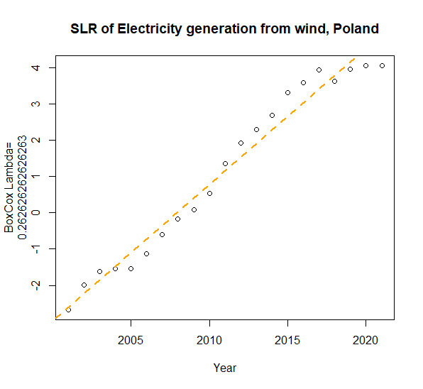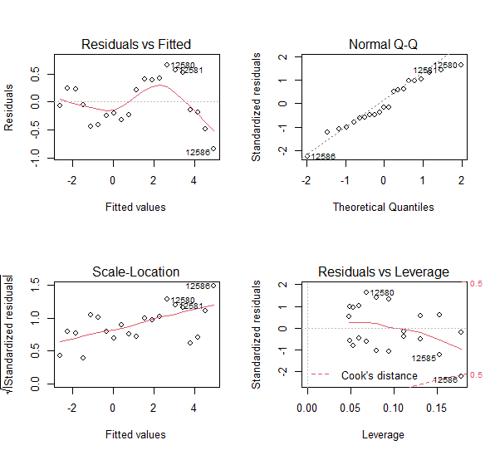

Again, analyze SLR model assumptions, make sure model is valid.

Get next 15 years prediction

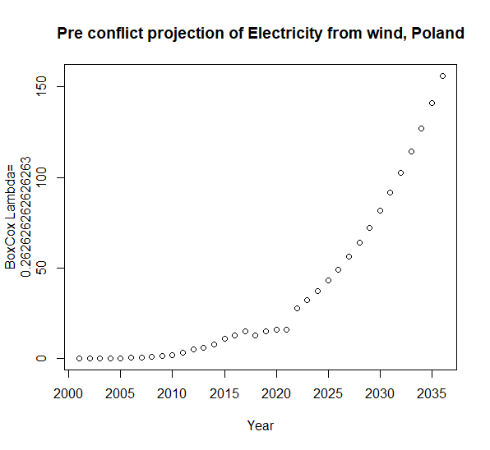

Plot Electricity generation from wind, measured in terawatt-hours, vs year, on Germany and Poland

Found out Poland wind adoption is 15 years behind

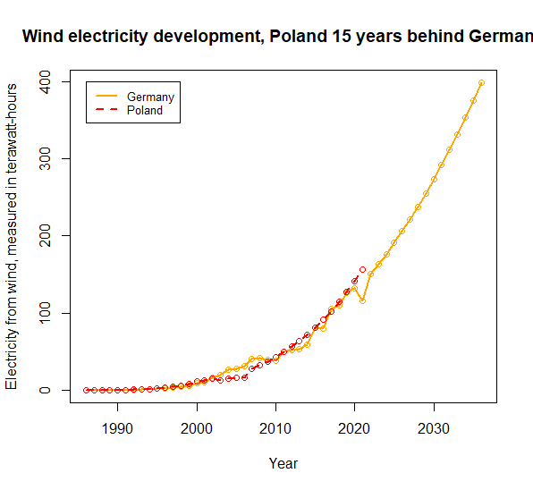

**Post conflict triggers faster adoption**

Business scenario-based assumptions

1. 2X accelerated, achieved 2036 projection in 2029
2. 3X accelerated, achieved 2036 projection in 2026

Use end date point goal to retrain both SLR models, and plot new projection paths.

Keep in mind that available wind energy (“floating wind”) is capped due to country size. Electricity from wind will reach to a ceiling and plateau growth curve. We will further optimize models (logistic regression) based on “floating wind” from each country.

Annual financial data from two European wind turbine players, Siemens-Gamesa, Ticker: GCTAY (OTCMKTS), and Vestas, Ticker: VWDRY (OTCMKTS).

Two sets of data

1. Wind turbine business financial data (revenue, optional: P/L, gross profit, mW sold), correlation with electricity generated from wind, exam correlation
2. Stock price of two businesses, exam correlation

Project Siemens-Gamesa’ and Vestas’ wind turbine business growth in next 15 years, using similar SLR method.

Convert wind turbine business potential revenue to company market cap, then provide investment guidance.

**Anticipated Conclusions/Hypothesis (what results do you expect, how will you approach lead you to determining the final conclusion of your analysis) Note: At the end of the project, you do not have to be correct or have acceptable accuracy, the purpose is to walk us through an analysis that gives the reader insight into the conclusion regarding your objective/problem statement**

Conclusion is wind turbine market sector will experience accelerated exponential growth in next few years. We will provide expected return with confidence intervals for the two companies we investigated.

**What business decisions will be impacted by the results of your analysis? What could be some benefits? - Felipe**

Our goal in this analysis is to predict long-term revenue potential for a firm that captures a large share of the emerging wind-energy market in a specific country, then use that to provide a stock price target. By successfully proving the first-mover advantage associated with capturing a previously coal-dependent market like Poland, our analysis could lead a firm such as Vestas Wind Systems A/Sor Siemens AG to shift focus and target the Polish market.

With demand for renewable energy consistently increasing over the years, and events like the Ukraine-Russia conflict accelerating adoption and the desire to shift away from fossil fuels, moving into markets that were previously dependent on traditional energy sources could drive significant revenues. In addition, successful implementation in one country could position Vestasor Siemens for significant growth across other emerging markets as wind-energy becomes a more readily available and cost-effective alternative. In short, by becoming the key player in Poland, Vestasor Siemens would create a lucrative foothold in Europe which could result in long-term revenue growth across emerging wind-energy markets.

Benefits associated include increased revenue, heightened brand recognition, customer loyalty, ability to capture large corporate/government contracts, price definition, and prime real-estate. Additionally, Vestas or Siemens would have the power to define the market and how it operates in Poland.

**PROJECT TIMELINE/PLANNING (2 points) - Kerri**

**Project Timeline/Mention key dates you hope to achieve certain milestones by:**

6/14/22 - Have Topic and Datasets Done and Listed in Teams – All members contributed evenly

6/17/22 - Have Proposal Draft Completed for Team to Review – All members contributed evenly

6/21/22 - Have Proposal and Datasets Submitted Before Due Date – All members contributed evenly

6/22/22 - Have Dataset in Datasource and All Members Set Up – All members contributed evenly

6/24/22 - Cleaning of Data Finished – Chris and Swathi

6/24/22 - Find 2 or 3 Research Papers for Progress Report Video

6/30/22 - Run Model on Sample Dataset

6/30/22 - Have Progress Report Video and Draft Completed for Team to Review

7/5/22 - Have Progress Report and Video with Slide Submitted Before Due Date

7/8/22 - Have Analysis/Coding Done

7/13/22 - Have Visualizations Done

7/15/22 - Have Final Drafts Completed for Team to Review

7/19/22 - Have Final Presentation Submitted Before Due Date

7/23/22 - Have Final Report, Slides, Data and Code Submitted Before Due Date

We will have weekly team meetings, meeting once or twice per week to go over target dates, divide up work and share independent progress reports with the team. We will either stick to schedule or be ahead of schedule and keep each other accountable. We will also assist team members when needed to meet target dates.

**Appendix (any preliminary figures or charts that you would like to include):**